## 

## horizontal line

**Software Requirement Specification for FIND YOUR MISSING**

21.06.2018

**─**

Prepared For

Dr.Amr El Said

Prepared by

Aya Shaban mahmoud

Mennatullah Hesham

Amal Asaad ibraheem

Mona Mohamed Abdelmohsen

Mariam Mohamed Bader Eldin

آية شعبان محمود

منة الله هشام

آمال آسعد إبراهيم

منى محمد عبد المحسن

مريم محمد بدر الدين أحمد نوفل

**Table**​ ​**of**​ ​**Contents**

1. **Preface​ ​​​.........................................................................................................​ ​**

**1.1. Document​ ​Purpose​ ​........................................................................................​**

**1.2. Target​ ​Users​ ​................................................................................................​..**

**1.3. Revision​ ​History​ ​.............................................................................................​**

1. **Introduction​ ​................................................................................................​ 2.1.Purpose​..........................................................................................................​**

**2.2.​ Survey​ ​ ​.......................................................................................................​**

**2.3. Scope​ ​............................................................................................​ ​​**

**2.4. Similar​ ​Systems​ ​...........................................................................................**

1. **Glossary​ ​............................................................................................................​ ​**

**3.1. Acronyms,​ ​definitions​ ​&​ ​abbreviations​ ​......................................................**

1. **System​ ​Users​ ​.....................................................................................................​ ​**

**4.1. System​ ​Stakeholders​ ​.....................................................................................​**

**4.2. Users​ ​objectives​ ​...........................................................................................​**

1. **User​ ​Requirements​ ​Definitions​ ​........................................................................​**

**​5.1. System​ ​Functions​ ​........................................................................................​ ​**

**5.2.Constraints ​.............................................................................................**

1. **System Functional Requirements ...............................................................**
2. **System Architecture………………………………………………………………..**
3. **System Non-Functional Requirements ................................................................**
4. **System​ ​Interfaces​ ​.................................................................................................​ ​**

**9.1. User​ ​Interfaces​ ​...........................................................................................​ ​**

**9.2. Hardware​ ​Interfaces​ ​.....................................................................................​ ​**

**9.3. Communication​ ​Interfaces​ ​.............................................................................​ ​**

1. **System​ ​(Use​ ​Cases​ ​​–​ ​Scenarios)​ ​...............................................................**
2. **System​ ​Modeling​ ​..................................................................................................​ ​**

**11.1 Class​ ​Diagram​ ​......................................................................................**

**11.2 DFD**

**11.2.1 Context Diagram ……………………………………………………...**

**11.2.2 Level 0 ………………………………………………………………**

**11.2.3 Level 1 ……………………………………………………………...**

1. **Work​ ​Plan​ ​............................................................................................................**

**12.1. Work​ ​breakdown​ ​structure​ ​(WBS)​ ​...........................................................​ ​**

**12.2. Gantt​ ​chart​ ​...........................................................................................**

1. **Future Work ………………………………………………………………**
2. **References​ ​..........................................................................................................**

**1. Preface**

1.1 Document Purpose

* The purpose of the document is to provide a detailed and completed description of the requirements for the “FIND YOUR MISSING” ( FYM) software.
* This document is primarily intended to be proposed to a customer for it’s approval and a reference for developing the first version of the system for the development team.

1.2 Target Users

* This document is composed by system engineers based on the requirements gathered from website owner in faculty of engineering Helwan university.
* This document is intended to be approved by the  
  website owner and the staff working on developing the system such as:

o Developers

o Testers

o Project manager

o Designers

1.3 Revision History

|  |  |  |  |
| --- | --- | --- | --- |
| **versions** | **Author** | **Description** | **Date** |
| 0.1 | **Mona** | **Initial version** | **6/5/2018** |
| 0.2 | **Amaal** | **Update structure** | **16/5/2018** |
| 0.3 | **Mariam** | **Update system models** | **2/6/2018** |
| 0.4 | **AYA** | **Final version** | **10/6/2018** |

**2. Introduction**

2.1 Purpose

FYM system is a website used to help people to find their missing relatives using Face Recognition Technology, where people can upload information and images of their missing relative, strangers who find anyone missing anywhere can upload information and image of that found one, system using Face recognition would make recognition between database of found and the other of missing, if there is a match then parent will be notified.

2.2 Survey

* This statistic shows the number of missing person files as listed by the National Crime Information Center (NCIC) from 2002 to 2017. In 2017, the number of missing person files was slightly more compared to previous years with 651,226 cases.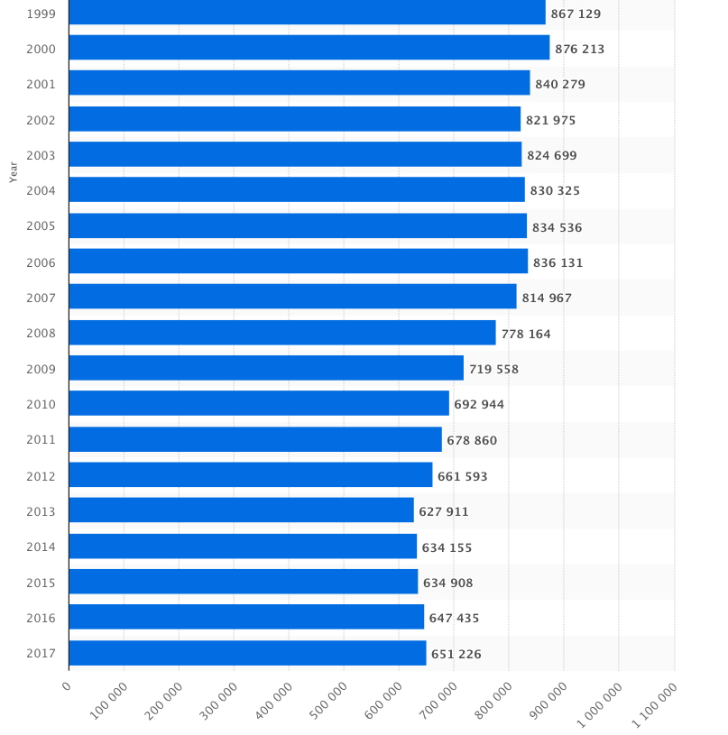
* The following charts reflect cases entered into the National Crime Information Centre’s (NCIC) Missing Person File during 2016 and are generated directly from data found [here](https://www.fbi.gov/file-repository/2016-ncic-missing-person-and-unidentified-person-statistics.pdf/view).

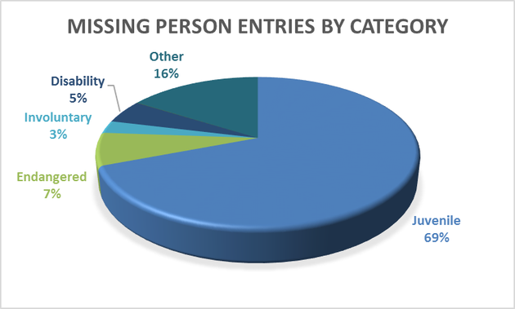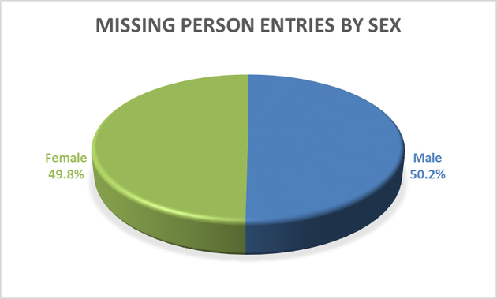

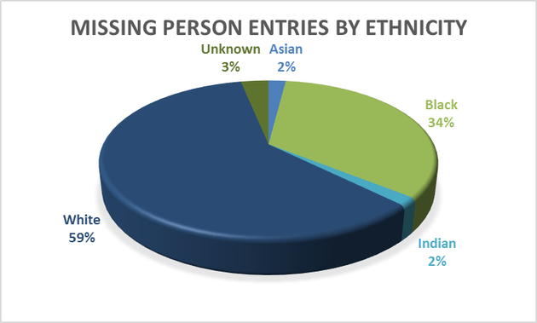

* As of year end 2016, the NCIC contained 88,040 active missing person records.

2.3 Scope

FYM system is a website used to help people to find their missing relatives using Face Recognition Technology.

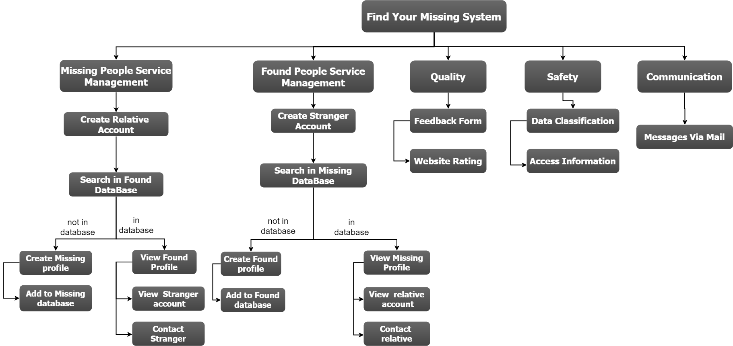

2.4 Similar Systems

some systems “websites” that have the same aim or objective like FYM:

|  |  |  |  |  |  |
| --- | --- | --- | --- | --- | --- |
| Point of comparison | FYM | Missing Kids | Baidu and Baby Back Home | khoya-Paya | uQR |
| Place | Over World | USA | China | India | Germany |
| By | Using Face recognition Technology | Posting posters about missing persons | Using AI Technology | Posting posters about missing persons | Live campaigns and posters |
| Target segment | All Segments  (Women, Men, Kids, Illness, people with special needs) | Kids | Kids | Kids | Kids |

**3.**​ ​**Glossary**

​3.1​ Acronyms,​ ​definitions​ ​and​ ​abbreviations

* FYM: Find Your Missing System
* SDD: Software Design Document
* Relative ID: Relative Identification Card Number
* WBS: Work Bread down Structure

**4. System Users**

4.1 System Stakeholders

**System Analyst**

o Responsible for requirements gathering.

o Responsible for deployment and support.

o Create SRS.

**System Designer**

o Recieve SRS.

o Create SDD.

**System Testers**

o Test the functionalities of the code.

**System Developers**

o Implement and maintain Software based on SDD.

**Software Owner**

o Add features.

o Edit features.

o Approve edits.

**Users**

o Relative to a missing person: add missing person , view missing and found person, receive a notification if his missing found in the found database.

o The one who finds a missing person: add found person, view missing and found persons.

**Administrator**

o Follow up with the website.

o Receive and respond to website feedback

4.1 User Objectives

**● System Engineers**

Our software team:

(System analyst, System testers, System designer, System developers)

o Gain experience in Software Engineering according to their roles.

**● Users**

o Relevant to a missing person: help to find their missing in best way to save time and money and separation around world.

o The one who finds a missing person: have a big and important role for backing the missing people to their relevant in short time and security way to save them.

**● Administrator**

o Ensure availability of the website

o Ensure security of users’ data.

o Ensure users’ satisfaction.

**5.**​ ​**User**​ ​**Requirements**​ ​**Definitions**

5.1 System Function

1. Register
2. Log in
3. Add missing profile
4. View missing profiles
5. View missing profile details
6. Add found profile
7. View found profiles
8. View found profile details
9. Log out

5.2 Constraints

• **Server breakdown**

1. Data overflow.

2. Maintenance breakdown.

• **Culture Constraints**

1. Trust issues.

**6. System Architecture**

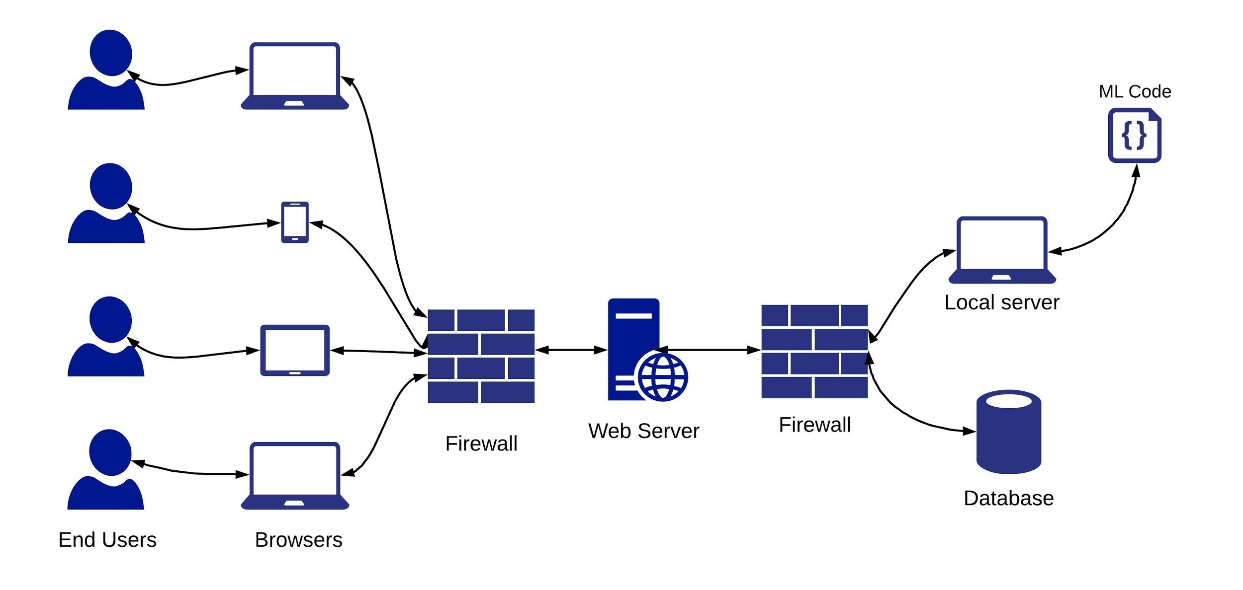

**7. System Functional Requirements**

7.1 Register

The user “website visitor” can add a new user account by adding the following information:

1. Username
2. Email address
3. Password

7.2 Log in

User to log in to the system needs to enter:

1. Username
2. Password

System verifies username and password.

7.3 Add missing profile

Any authorized user can add a profile of a missing person “user must have a family relation with the missing person”, to add a new profile the user needs to add the following information about his missing:

First Name

Second Name

Sex (Male / Female)

Age (Before being missing)

Date Of Birth

Hair Colour

Eyes Colour

Weight

Height

Missing From (Last place watched at)

Missing Date (Last date watched at)

Relative ID (User ID)

Relative Relation (User family relation with the missing person)

Details (More detailed information about the missing one)

Missing Person Image (A clear recent image of the missing person)

7.4 View missing profiles

Any authorized user can view all missing persons profiles including the profiles that he had added before, the list of missing profiles shows:

1. Image of the missing person
2. First Name of the missing person

7.5 View missing profile details

Any authorized user can view all information of a certain missing person by viewing his profile which include the following information:

1. First Name
2. Second Name
3. Sex (Male / Female)
4. Age (Before being missing)
5. Date Of Birth
6. Hair Colour
7. Eyes Colour
8. Weight
9. Height
10. Missing From (Last place watched at)
11. Missing Date (Last date watched at)
12. Missing Person Image (A clear recent image of the missing person)
13. Details (More detailed information about that missing one)

7.6 Add found profile

Any authorized user can add a profile of a found person “user must have seen the found person recently”, to add a new profile the user needs to add the following information about the person he has found:

* Sex (Male / Female)
* Found In (Place recently watched at)
* Found Date (Date recently watched at)
* Location (Where he is now if the user has taken him to some governmental place)
* Details (More detailed information about that missing one)
* Found Person Image (A clear recent image of the found person)

7.7 View found profiles

Any authorized user can view all found persons profiles including the profiles that he had added before, the list of found profiles shows images of the found persons

7.8 View found profile details

Any authorized user can view all information of a certain found person by viewing his profile which include the following information:

* Sex (Male / Female)
* Found In (Place recently watched at)
* Found Date (Date recently watched at)
* Location (Where he is now if the user has taken him to some governmental place)
* Details (More detailed information about that missing one)
* Found Person Image (A clear recent image of the found person)

7.9 Log out

Any authorized user when log out the system he can’t access any data or adding any data

**8. System Non-functional Requirements**

8.1 Availability

* System should be available during working and non-working hour.
* The system will run 7 days a week, 24 hours a day.
* Availability of 99.8% should achieved.
* Maintenance time will be according to website statistics to decide when is a best time for the outage.

8.2 Security

* Users shall be required to log in to the (Find Your Missing) System for all operations.
* The system shall permit only staff members to create or edit website information updates.
* Only users who have been authorized could upload photos to website .
* Access permissions for application data may only be changed by the system’s data administrator.
* Password storage system uses [“PBKDF2](https://en.wikipedia.org/wiki/PBKDF2)” algorithm with a “SHA256” hash (safe password hash).
* system guaranties:

→ XSS (cross-site scripting) protection.

→ CSRF (cross site request forgery) protection.

→ SQL injection protection.

8.3 Maintainability

* In average, the system should have a maintainability index of 95%.
* A commercial database will be used for maintaining the database and the application server takes care of the site. In case of a failure, a re-initialization of the program will be done. Also the software design is being done with modularity in mind so that maintainability can be done efficiently.

8.4 Efficiency

→ Throughput: The system can process 600 request per hour. (Can be  
increased due to usage measurements).

→ Response time:

|  |  |
| --- | --- |
| Transaction Category | Response Time SLA (sec) |
| Simple | 3 |
| Medium | 6 |
| Complex | 10 |

* Simple Transactions: The response time for simple transaction should be 3 seconds or less. Transactions such as page navigation are examples of simple transaction.
* Medium Transactions: The response time for medium transactions should be 6 seconds or less. Submitting information .
* Complex Transactions: The response time for complex transactions should be 10 seconds or less.(uploading photos )

8.5 Usability

* The system’s user interface is intuitive, easy to use and provide an overall positive user experience.
* People with no technical experience shall easily use (website)
* An online help system is available. (contact us form)
* Response time for emails within a day.( Supportability)

8.6 Portability

* The end-user part is fully portable and any system using any web browser should be able to use the features of the system, including any hardware platform that is available or will be available in the future.
* An end-user is use this system on any OS; either it is Windows or Linux.
* The system shall run on PC, Laptops, and PDA etc.

**9.​ ​System​ ​interface**

9.1. User​ ​interfaces​ ​

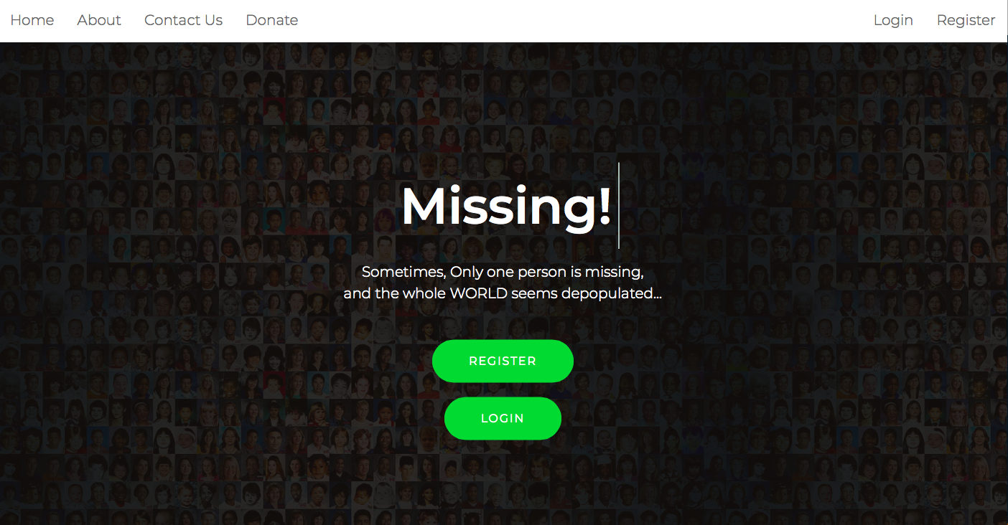

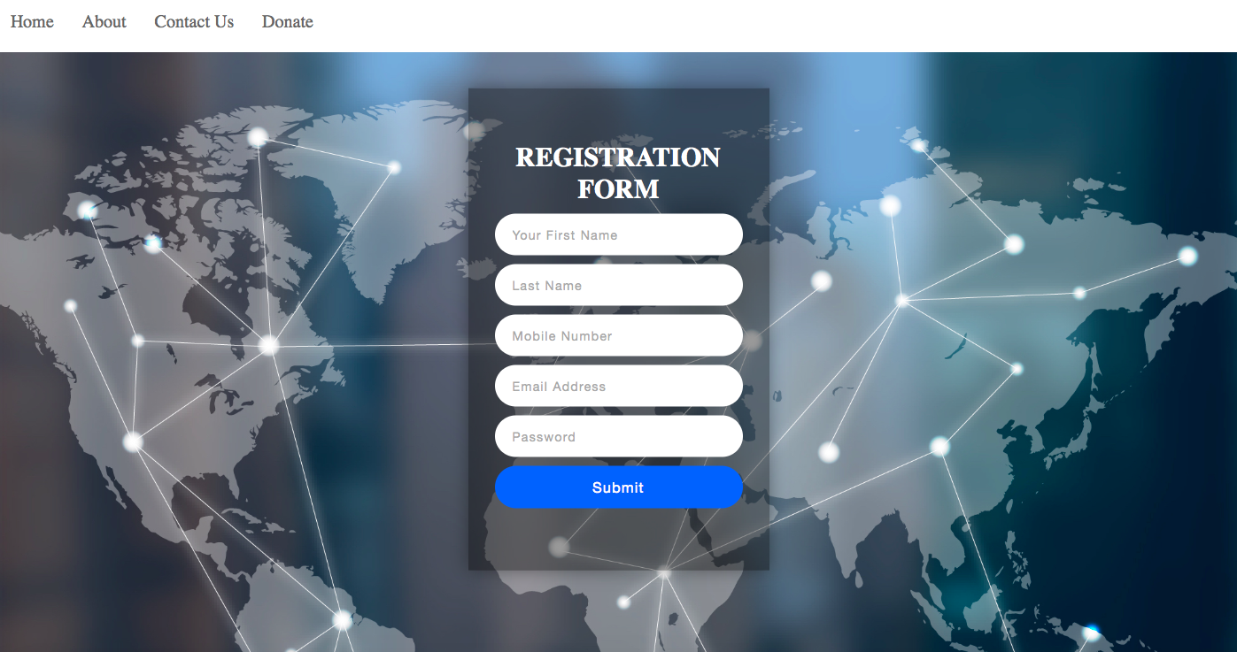

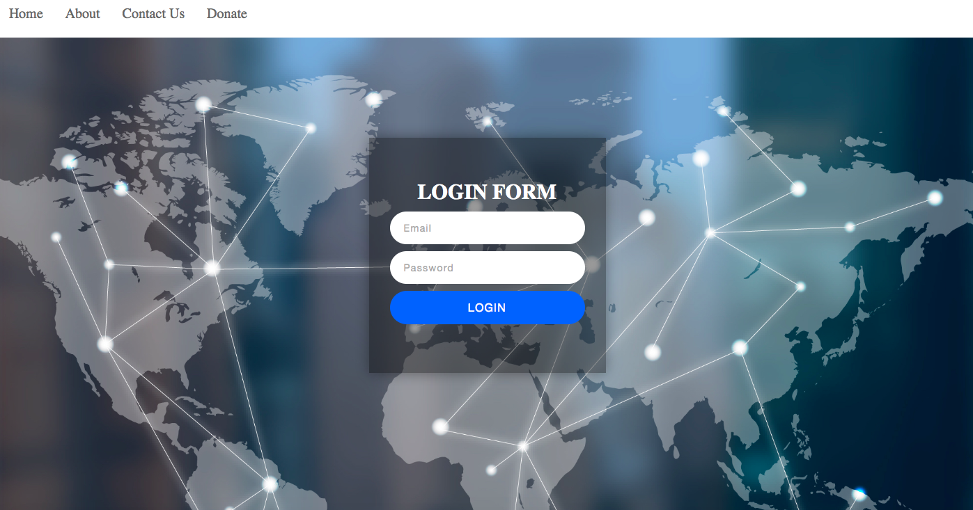

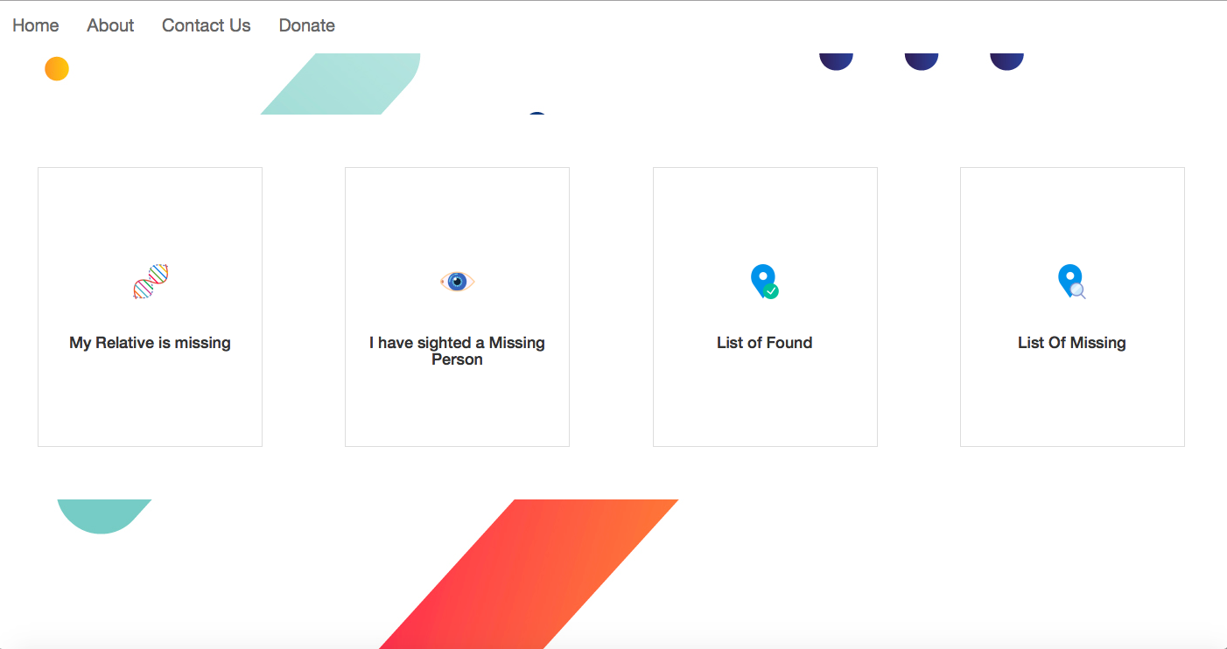

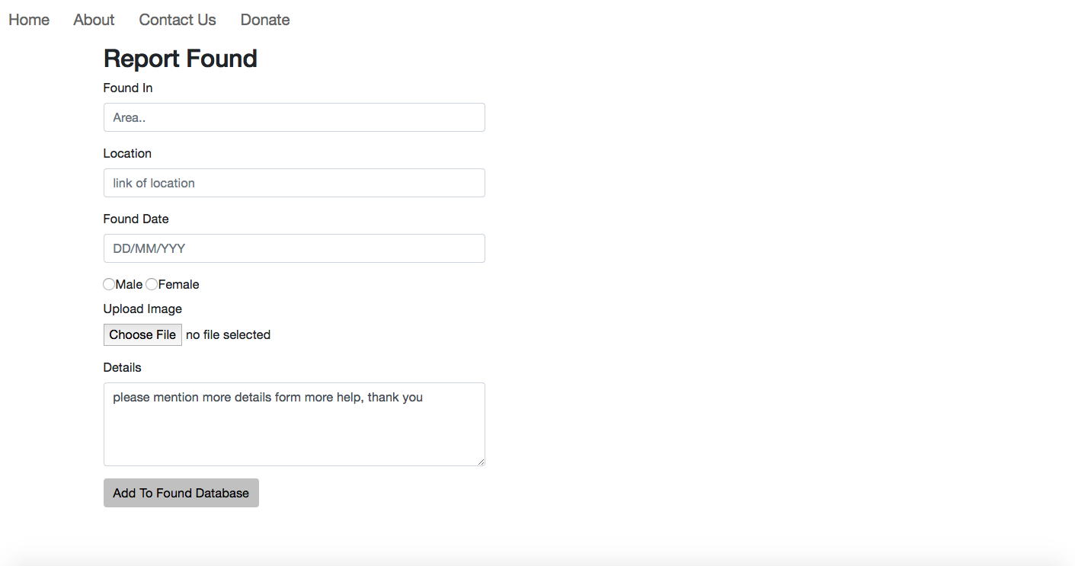

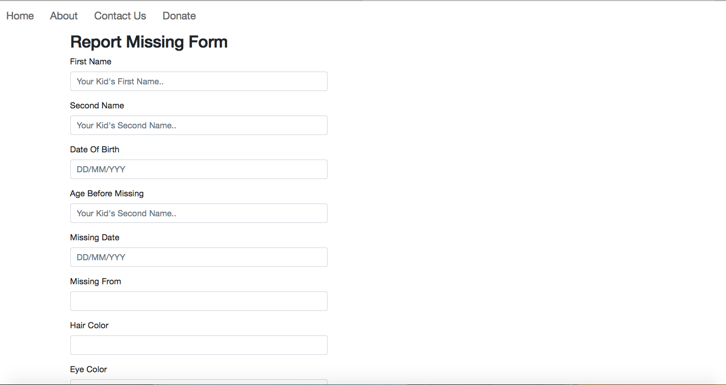

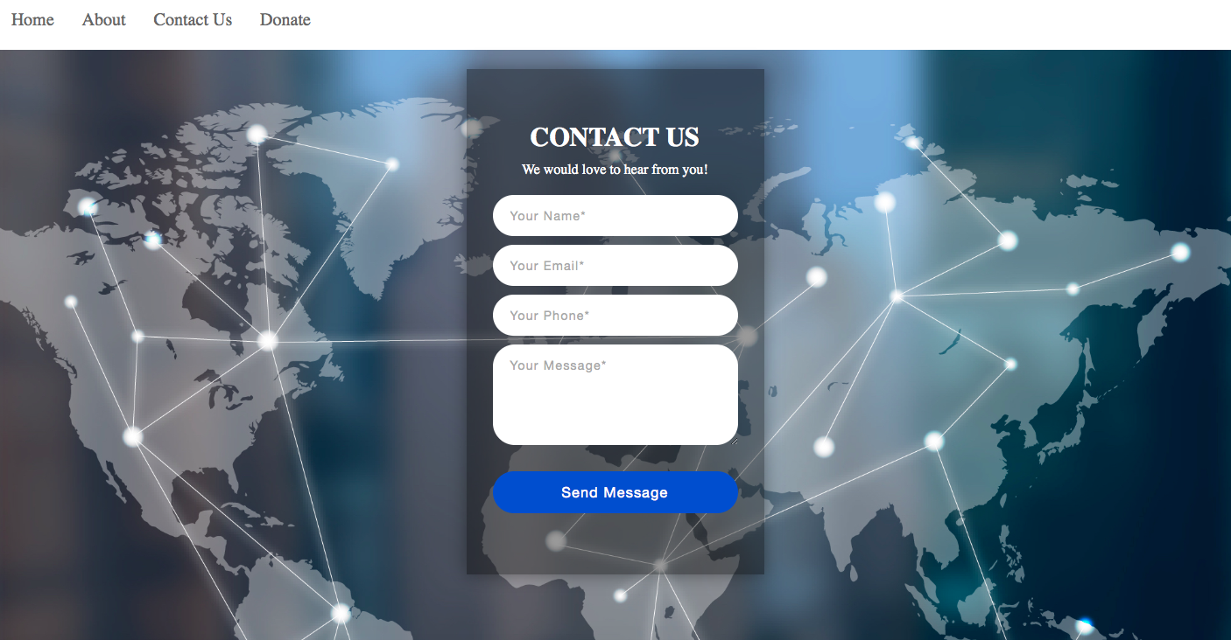

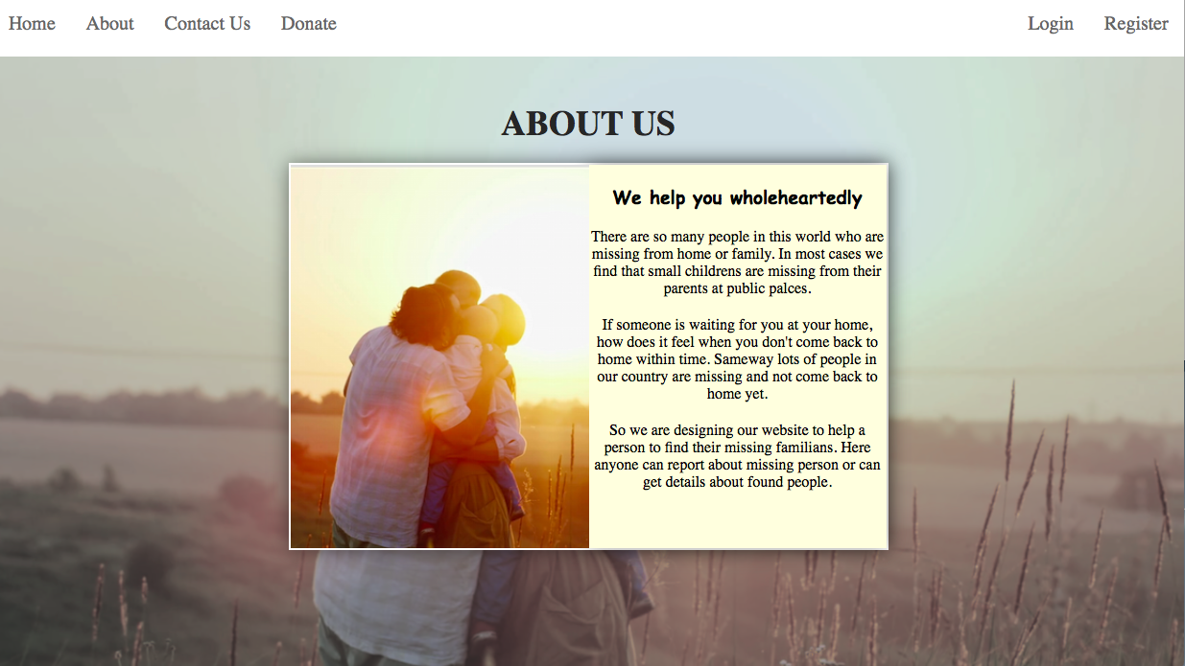

9.2 Hardware​ ​interfaces​

Since​ ​the​ ​application​ ​must​ ​run​ ​over​ ​the​ ​internet,​ ​all​ ​the​ ​hardware​ ​shall​ ​require​ ​to​ ​ connect​ ​internet will​ ​be​ ​hardware​ ​interface​ ​for​ ​the​ ​system.​ ​As​ ​for​ ​e.g.​ ​Modem,​ ​WAN​ ​ –​ ​LAN,​ ​Ethernet​ ​Cross-Cable.

9.3 Communication interface

* Find your missing shall use the HTTP protocol for communication over the Internet and the internet communication will be through TCP/IP protocol .
* Information transmission should be securely transmitted to server without any changes in information through Web Site encryption by using SSL.

**10.​ ​System​ ​​(Use​ ​cases​ ​–​ ​Scenarios)**

10.​1 ​Use case diagram

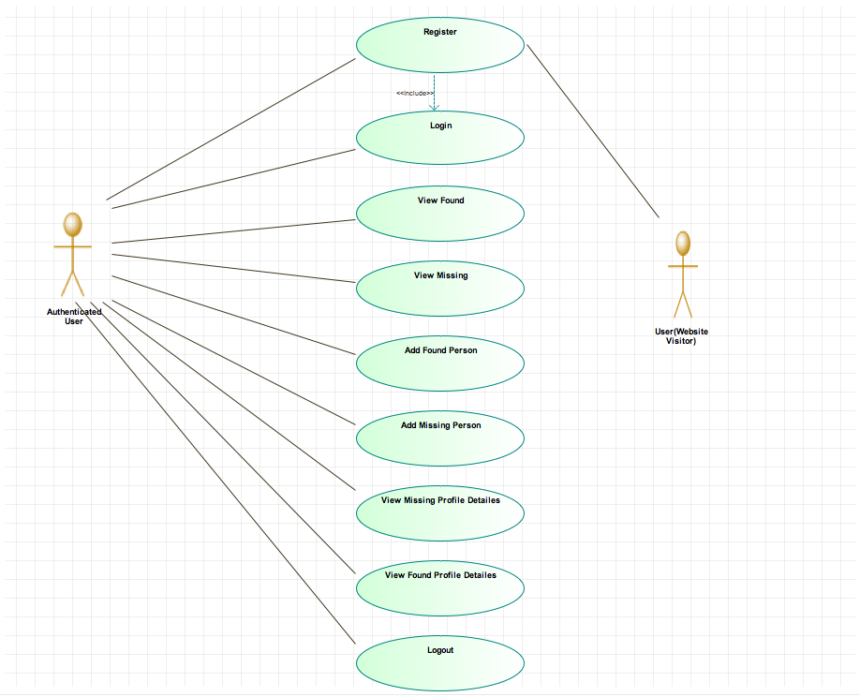

10.​2 ​Scenarios

10.2.1 Register Scenario

***Participating Actors***: User & System.

***Entry Condition:*** A Person (user) visit the website and would like to use it.

***Exit Condition:*** user click submit button. Or he select

Cancel or back.

***Quality Requirements:*** Performance system can verify account and

created during 60 second.

***Related Requirements:*** Edit and Delete Account.

***Typical Flow of Events:*** User select register so system invokes create

account use case which let the user fill the following information:

● User name.

● E-mail address.

● Password.

Then user select submit so that invoke the system to check those data and

verified it.

***Alternative:*** none.

***Exceptions****:* his data not verified (Mail, password,username) or less than 18 years old.

10.2.2 Add missing profile Scenario

***Participating Actors:*** authenticated user

***Entry Condition:*** A Person (authenticated user) sign in then select add missing

person.

***Exit Condition:*** he select Cancel or back or submit the profile.

***Quality Requirements:*** Performance system can add profile in view missing in

website within 5 min after apply face recognize on uploaded photo.

***Related Requirements:***

* user must have a family relation with the missing person.
* System apply face recognize on the profile and add it into view missing.

***Typical Flow of Events:*** the user select add task and that invokes add task use

case which let the authenticated person add those information.

* First Name
* Second Name
* Sex (Male / Female)
* Age (Before being missing)
* Date Of Birth
* Hair Colour
* Eyes Colour
* Weight
* Height
* Missing From (Last place watched at)
* Missing Date (Last date watched at)
* Relative ID (User ID)
* Relative Relation (User family relation with the missing person)
* Details (More detailed information about the missing one)
* Missing Person Image (A clear recent image of the missing person)

Then the user select submit Which make system invokes face recognize Use Case.

***Alternative:*** None.

***Exception:*** the user doesn't fill all data or information we need it to creat

missing profile.

Or it's illegal person not relevant to the missing or banned from the system in case

someone report it as doubtful one.

10.2.3 Add found profile Scenario

***Participating Actors:*** authenticated user.

***Entry Condition:*** A Person (user) sign in then select add found person.

***Exit Condition:*** he select Cancel or back or submit.

***Quality Requirements:*** Performance system can add profile in view missing in

website within 5 min after apply face recognize on uploaded photo.

***Related Requirements:*** System apply face recognize on the profile and add it into

view found.

***Typical Flow of Events:*** the authenticated user select add found profile and that

invokes add found use case which let the user add those information.

* Sex (Male / Female)
* Found In (Place recently watched at)
* Found Date (Date recently watched at)
* Location (Where he is now if the user has taken him to some governmental place)
* Details (More detailed information about that missing one)
* Found Person Image (A clear recent image of the found person)

System invokes face recognize Use Case .

***Alternative:*** None.

***Exception:*** the user doesn't fill all data or information we need it to creat

found profile.

or it’s banned person from the system in case someone report it as doubtful one.

1. ​**System**​ ​**Modeling**

11.1. Class​ ​diagram

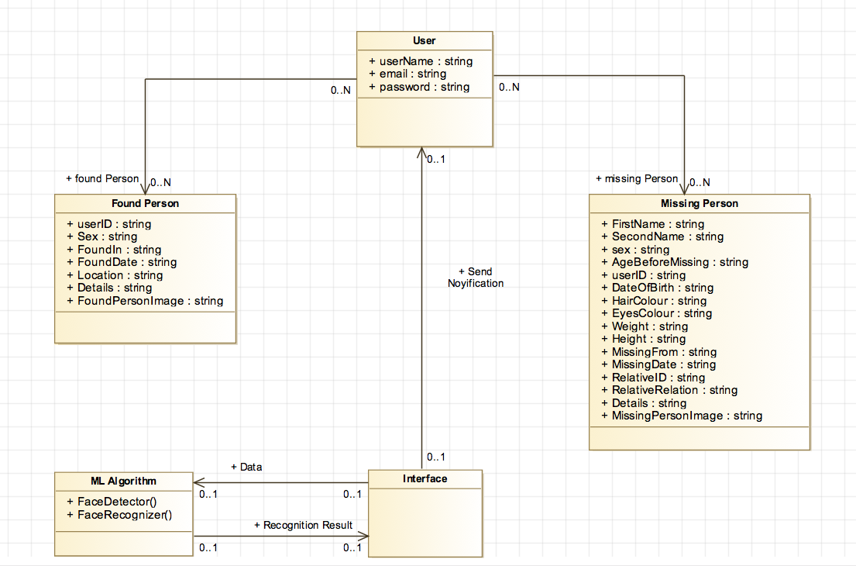

11.2. Data Flow ​diagram

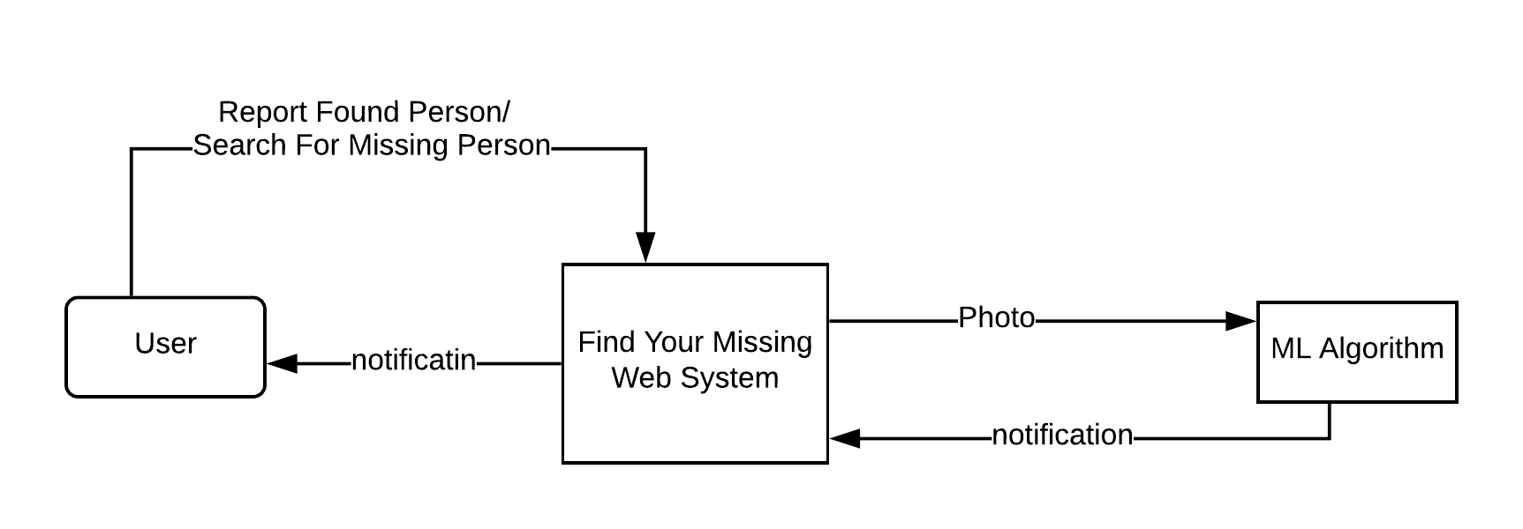11.2.1 Context diagram

11.2.2 Level 0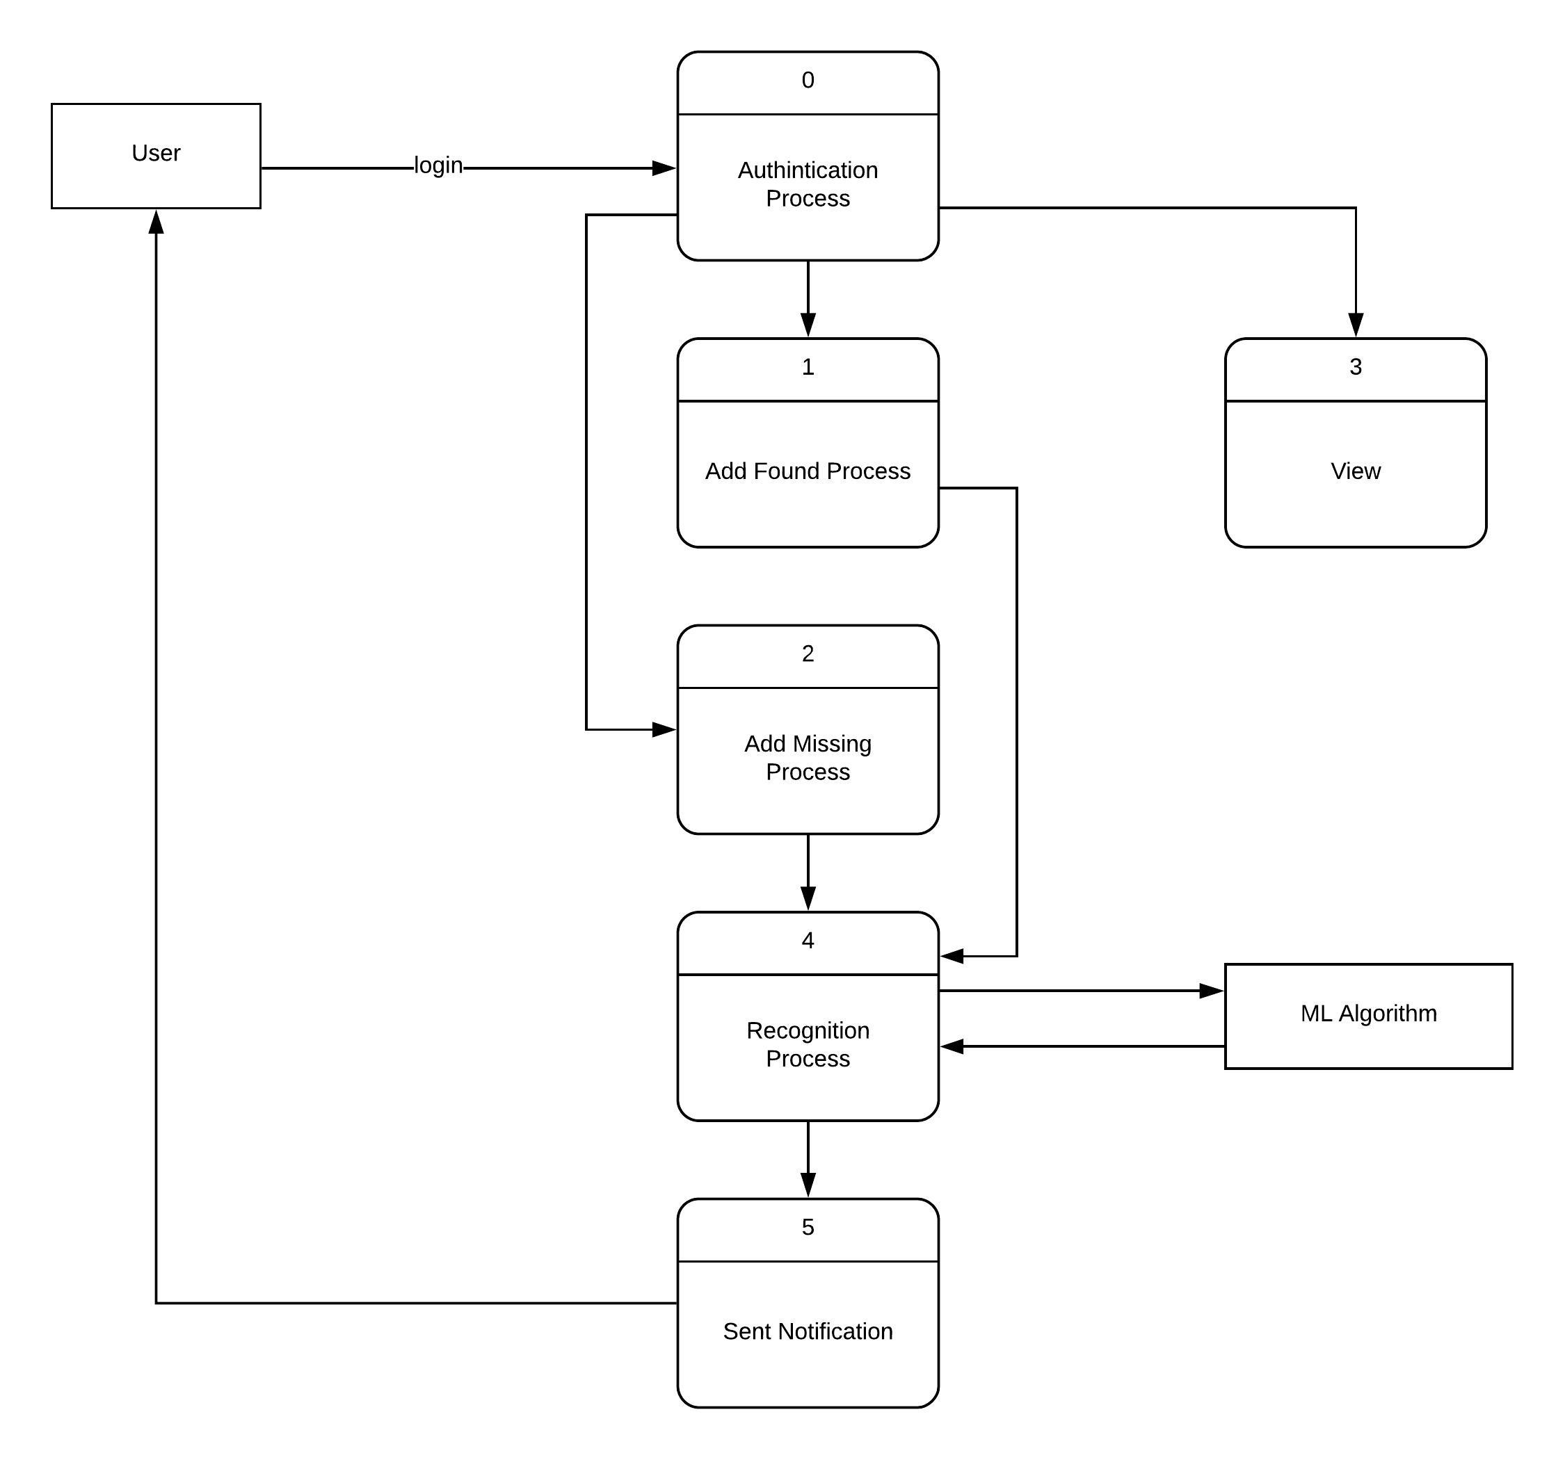

11.2.3 Level 1

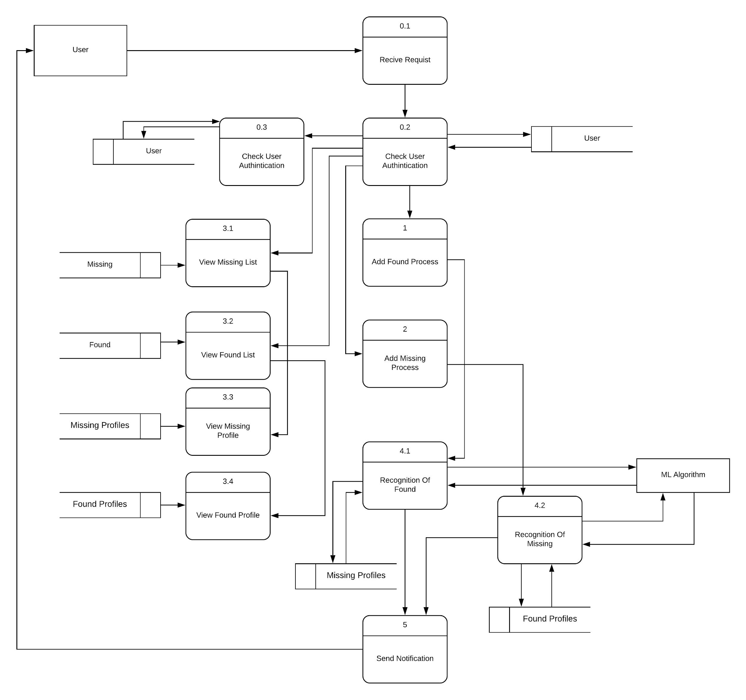

**12.**​ ​**Work**​ ​**Plan**

12.1​​ ​​Work​ ​Break​ Down​ ​Structure​ ​(WBS)

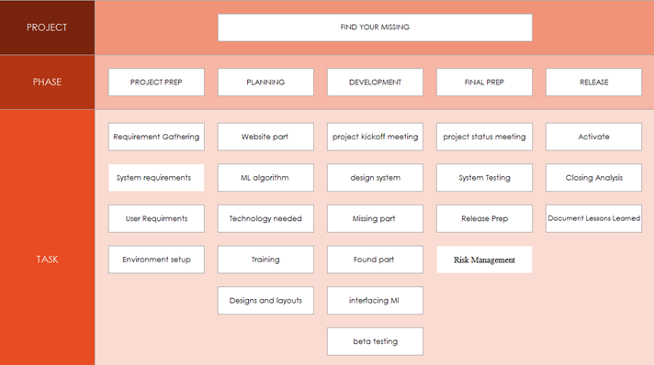

12.2​ ​Gantt​ ​Chart

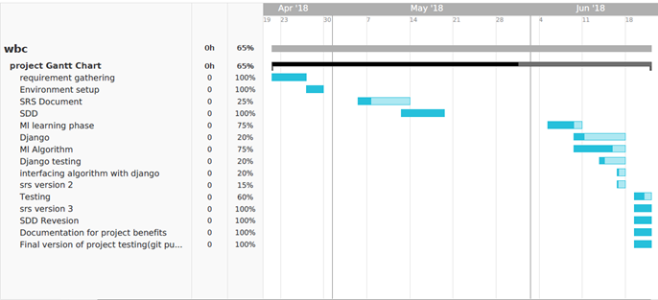

**13. Future Work**

As Ai Always growth and the advances in technology could help that process become more automated or even improve accuracy, so we aim to achieve this goals

Future Functions To be added :

1. Mobile application:

→ we wish to design a mobile application to make it more easy to access (Found person) location and upload multiple photos of him so the founding process will be more easily and fast in time .

2. Algorithm development :

→ Machine learning algorithm for face Recognition will be developed for more accuracy and less time to achieve

3. Monthly Report :

→ Monthly generated report about matched persons that we found in our database.

4. Psychological aid:

→ As we believe that Psychological aid is so important to a parent with missing child or a home with missing person so we will provide a functionality to leave a good words to those who having previous experience with that situation to support each others.

5. Age progression:

→ we envisions more application of age progression — and regression — to facial images.

→ Once a child has been missing for multiple years, a computer model could simulate how that person might look in the present day.

6. back in time:

→ Conversely, will be possible to create a connected app that allows uploading of a current picture and then use the modeling process to look back in time, in order to see if a younger version of that face matches a missing person report.

7. Camera for real-time Recognitions:

→ In a crowded place like a subway station, which has surveillance cameras in place, AI could help spot faces that match people in the missing persons database, so if we have a massive computing power it will guarantee our future dreams to help every person with a missing!

8. Website:

→ The website would be re-designed and re-developed,

as we will split the 2 databses into a lot number of databases so each state or country would have its own database, its own language and also an interface.

**14.**​ ​**References**

14.1 Survey

→<https://ihavevanished.com/statistics/>

→<https://www.fbi.gov/file-repository/2016-ncic-missing-person-and-unidentified-person-statistics.pdf/view>

14.2 Similar systems

→ <http://api.missingkids.org/home>

→<https://www.geospatialworld.net/videos/geobytes/artificial-intelligence-helps-find-missing-children-china/>

→ <http://khoyapaya.gov.in/mpp/home>

→<https://uqr.me/blog/initiative-vermisste-kinder-missing-children/>

14.3 UML Diagrams:

→<https://www.lucidchart.com/users/login#docs?folder_id=home&browser=icon&sort=saved-desc>